OUTREACH ONCOLOGY CLINIC

Oncology Nurse Practitioner (Helen Goodall), McGrath Breast Care Nurse (Rachael Stevens) and Oncology Social Worker (Fiona Ord)

Providing follow-up, management of side effects of treatment, information, support, lymphoedema management, emotional support, financial information and so much more!

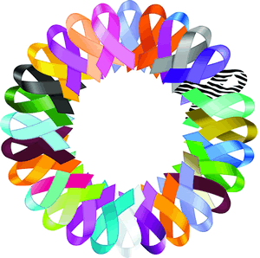
VISITING INVERELL IN 2018 ON:

10-3pm (by appointment)

8th February
19th April
14th June
9th August
11th October
13th December

Please call Helen Goodall on 02 67769971 (feel free to leave a message) to make an appointment or email to
helen.goodall@hnehealth.nsw.gov.au

